**Name:**

***Full working out must be shown to get full marks.***

***Attempt all questions***

**Total Time: Part A- 40 mins (40 Marks)**

**Part B- 15 mins (17 Marks)**

**Non Calculator Section**

TIME ALLOWED: 40 min Total marks: 40

**Question 1**  [**1, 2 = 3 marks]**

The function  is given by .

1. Determine the coordinates of all axes intercepts of the graph of .
2.  can also be expressed in the form . Determine the value of the coefficient .

**Question 2 [ 2, 2 = 4 marks]**

a) Determine the equation of the circle shown below.

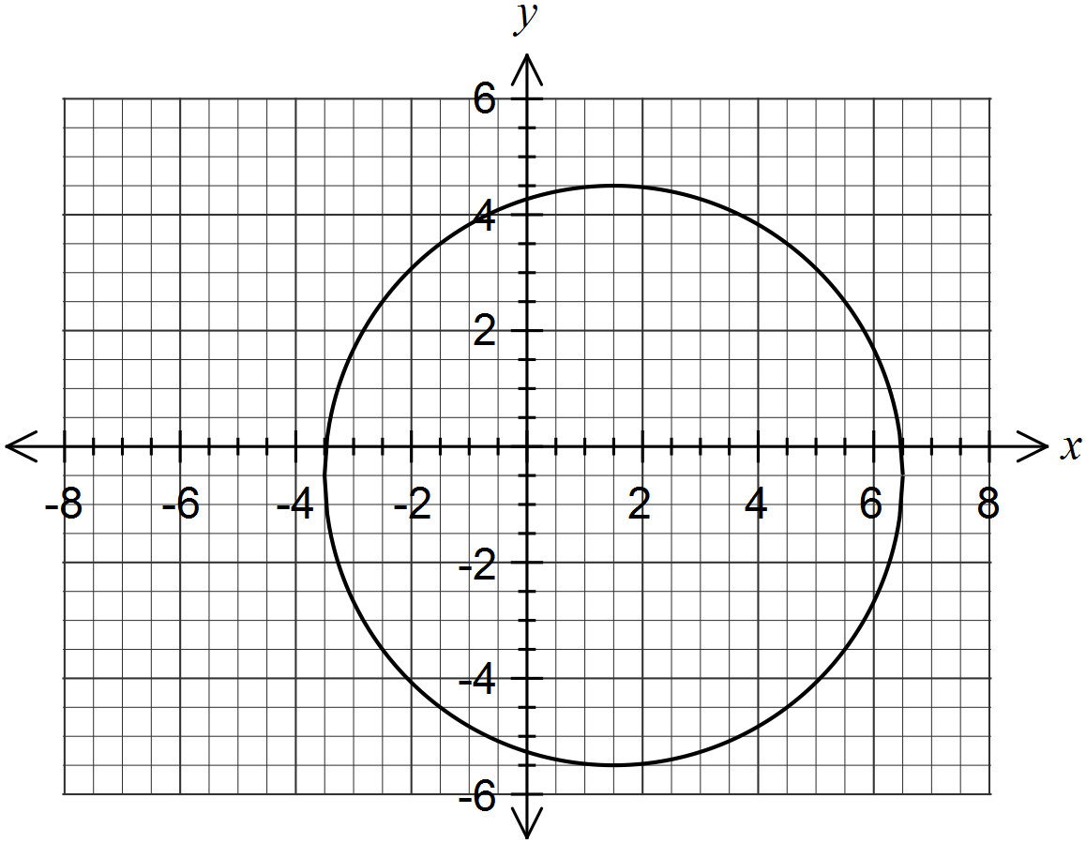

(b) Determine the radius of the circle with equation .

Question 3 [1, 2, 2 = 5 marks]

Given that $x^{3}-8x^{2}+19x-12=\left(x-3\right)\left(x^{2}+bx+c\right):$

1. Determine the value of c by inspection.
2. With your answer from part (a) in place of c determine b.
3. Factorise $x^{3}-8x^{2}+19x-12$

Question 4 [1, 1, 1- 3 marks]

|  |
| --- |
|  |
| Give the amplitude and period for each of the following: |
| |  |  |  | | --- | --- | --- | | Function | Amplitude | Period | | a) |  |  | | b) |  |  | | c) |  |  | |

Question 5 [2, 2 - 4 marks]

|  |  |
| --- | --- |
|  |  |
|  | Give the equation of each of the following graphs: |
| **a)** | EQUATION : |
| **b)** | EQUATION: |

**Question 6 [2, 4- 6 marks]**

|  |  |  |  |
| --- | --- | --- | --- |
|  | Solve for | | |
| **a)** |  | **b** |  |
|  |  |  |  |
|  |  | | |

Question 7 [2, 1- 3 marks]

Find the exact value of:

1. $\tan{\frac{4π}{3}}$ = b) $\sin^{2}\left(\frac{π}{41}\right)+\cos^{2}\left(\frac{π}{41}\right)$ =

Question 8 [ 3, 3 - 6 Marks]

Solve for $θ$ within the given domain.

a) $\left(cosθ\right)\left(2sinθ-1\right)=0$ where $0≤θ≤2π$

b) $\sqrt{2}\sin{θ}=-1$ where $0≤x≤360°$.

Question 9 [3, 3- 6 marks]

Use an appropriate trigonometric identity to find the exact value of:

(a) sin 75°

(b) $\tan{(})$

End of Part A